**Meet Our New CIOA Carrot Varieties!**

* Developed to diversify carrot types for organic growers with novel colors, nutrition, pest and disease resistance, and quality tops (weed competition).
* Open-pollinated and bred from carrot lines out of the USDA Agricultural Research Services breeding program led by Dr. Philipp Simon.
* Release processes underway to make seeds publicly available in the next year.
* Will not be restricted by intellectual property and growers are welcome to save, select, adapt and sell seed into the future!

**OSA Strain Cross**

* Un-named variety developed since 2012 from a cross of six parents that included lines with high ß-carotene (dark orange), good flavor, Alternaria and nematode resistances.
* The multi-parent cross was selected as roots on farms in Virginia, Vermont, Wisconsin, Indiana, Washington, and California. Seed was regenerated at the Organic Seed Alliance (OSA) farm in Washington.
* Breeding goal: A genetically diverse, Nantes type carrot with good flavor, deep orange color, strong tops, and generally adaptable to diverse environments.

**Purple-Orange-Purple**

* Cross selected for purple exterior and purple core with an orange cambium in between, creating a beautiful “bull’s-eye” effect!
* With anthocyanins providing the purple, and ß-carotene providing the orange colors, this cross is a superfood with the numerous health benefits of these pigments!
* Bred for improved flavor, selected in every generation, along with beauty, and the unique visual appearance.

**Fantasia**

* Unstable and highly diverse population originally created by Dr. Micaela Colley as an educational project with elementary school students!
* Together they created a mix of colors and qualities by selecting the tastiest, most beautiful roots across the USDA germplasm.
* After a few years of this process with the school program, the population generally became much more flavorful than the original parents, and gained vigor (root and top size), and interesting intersections of colors emerged in individual roots.
* With the great interest in this “rainbow” carrot, it was shared for ongoing selection and seed sales.
* Sold online by Ujamaa Seed [https://ujamaaseeds.com](https://urldefense.com/v3/__https:/ujamaaseeds.com/__;!!Mak6IKo!O9rYDyh3D3RLur1RS2nNa0rstXED43XXWiAB2sRN1RbLBAeQ4zFb_ltWsomlvl3RVRRN8tQEVnGEkJgod2XZtms$) and a few other packet businesses.

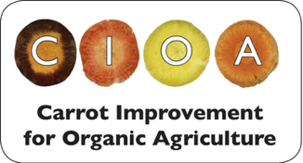

**For more information:**

**CIOA** https://eorganic.info/carrotimprovement/about

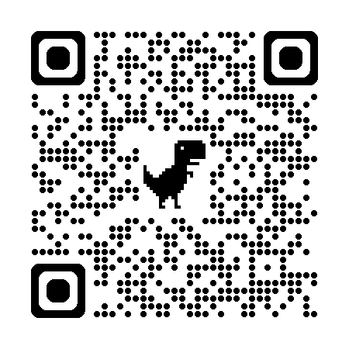

**Organic Seed Alliance** https://seedalliance.org/

